James Nieh Public Biography

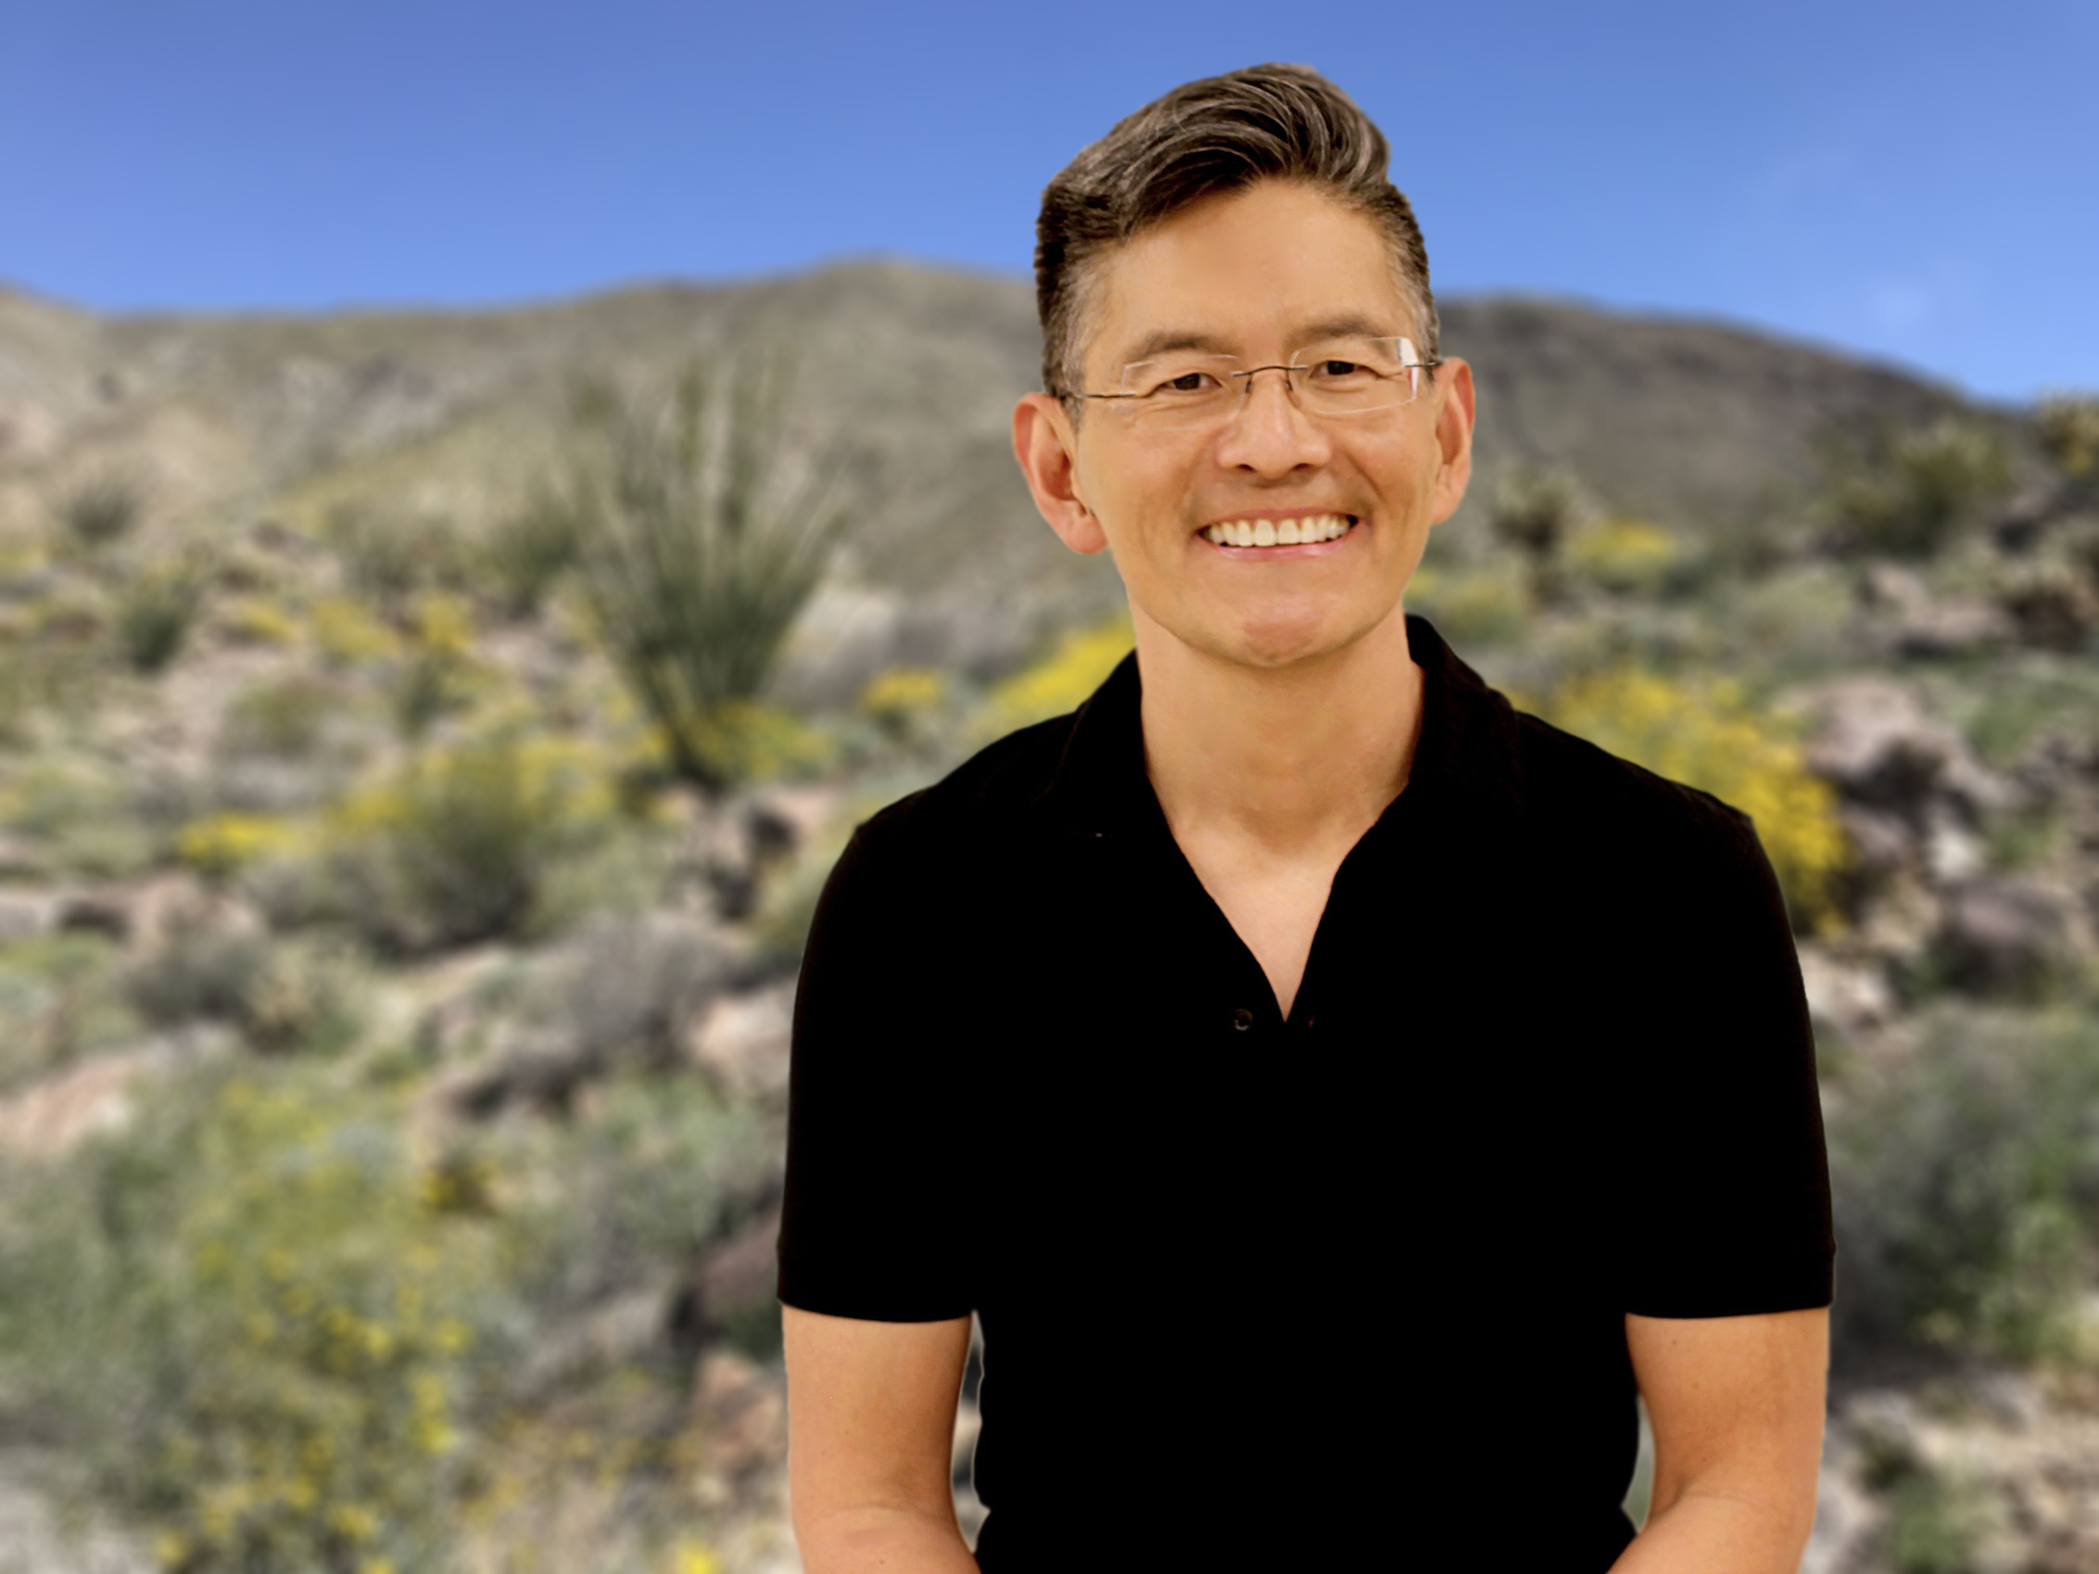
Professor James C. Nieh was born in Taiwan, and grew up in Southern California. He received his B.A. at Harvard in 1991 and his PhD from Cornell University in 1997. He subsequently received a NSF-NATO Postdoctoral fellowship to study at the University of Würzburg in Germany. After this, he received the prestigious Harvard Junior Fellowship. In 2000, he joined the faculty in the School of Biological Sciences at the University of California San Diego where he is a professor in the Department of Ecology, Behavior, and Evolution. He held the Heiligenberg Chair of Neuroethology, was chair of his department, and was elected Fellow of the Royal Entomological Society in 2017. He is an Associate Dean in the School of Biological Sciences.

Dr. Nieh’s interests focus on bee communication, cognition, and health. He studies many types of social bees, including honey bees, bumble bees, and stingless bees. His lab studies natural and man-made stressors of social bees. A major part of his work focuses on foraging and communication in honey bees and honey bee health. The research on honey bee health focuses on how pesticides alter honey bee behavior and learning, how a common pathogen, Nosema ceranae, infects bees and alters their behavior, how honey bee immunity can be boosted to fight Nosema infection, how the bee gut microbiome may help us find new ways to counter Nosema infection, and how a nutritionally balanced diet can help bees exposed to pesticides.

Scan this QR code to learn more about the lab’s research

